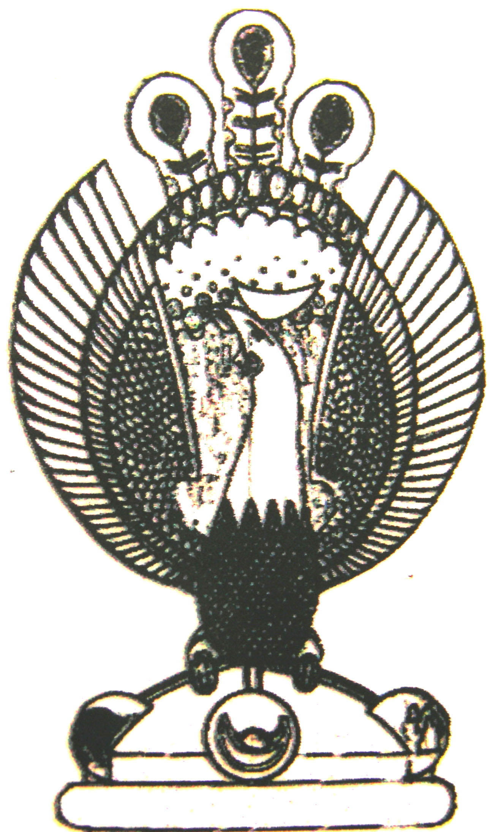

THE HERITAGE

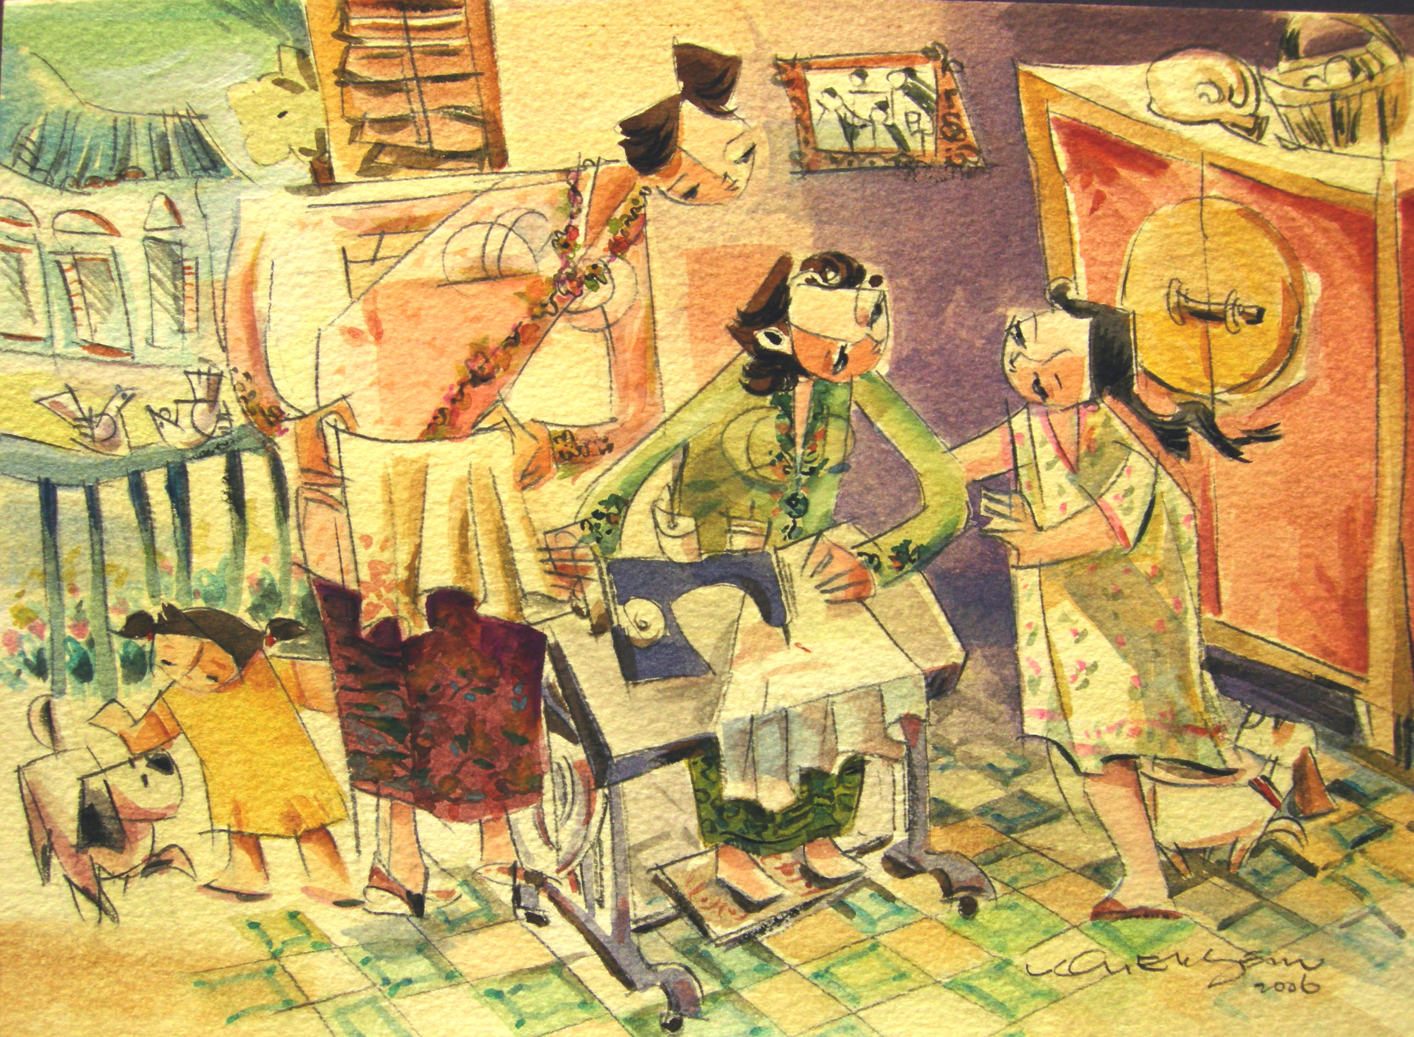
Embroidery and sewing
The materials used were not just obtained locally. The beads, threads and sewing instruments could be imported from China, Italy or England. Only the best materials would satisfy the fastidious nature of the Peranakan Lady

